TITLE: JAVA MINI PROJECT

|  |  |
| --- | --- |
| Group 13 |  |
| 5021129 | 0m Mahajan |
| 5021153 | Sahil Prasad |
| 5021155 | Shantaram Sawant |

INTRODUCTION:

Our java mini project group has 3 members 0m Mahajan, Sahil Prasad, Shantaram Sawant under the guidance of Mam' Sharlene Rebeiro and our finalised idea for this mini project involves developing a better feature to get more accurate songs recommendation.

PROBLEM STATEMENT:

To develop a feature to solve the issue of Irrelevant search results in popular Music App like hungama, wynk.

LITERATURE SURVEY:

1. Saavn

Saavn was the first online music streaming service in India launched back in 2007. Saavn has 13 million active user base in India monthly. This music app offers unlimited streaming without having to purchase the songs. In case if you want to download you need to upgrade your account to premium version which is called as Saavn Pro. This app is available on Android, iOS, and desktop as well. It has over 7 million songs collection in 12 languages.  
  
Pros

Simple user interface Audio Series

Shows are updated regularly

Feature available to follow your friends

Cons

Bitrate of the songs

Discovery mode must be turned on automatically

Bad as a music player for songs on your phone.

1. Gaana

Another music streaming service that is on par or maybe above Saavn is definitely is the Gaana. Launched in 2010, it has over 10 million song collections. This app also offers unlimited music streaming with ads and need to upgrade to Gaana+ for downloading songs in high quality.

Pros

On-screen Equalizer

Video catalogue

Feature available to follow your friends

Cons

Notification on daily basis

Take times to stream

Unavailability of new content at launch time

3. Wynk

Bharti Airtel's most successful app till now is undoubtedly the Wynk music player. This app has a collection of over 2.5 million+ songs in over 12 regional languages. However, there is a catch here--Non-Airtel users can stream up to 100 songs per month, while Airtel users can stream unlimited  
  
Pros

Easy to use

Good collections even though not vast

Cons

Biased

Streaming takes time

1. Jio Music

This streaming service has a vast number of collection even though the company didn't reveal about it. It is free and available in over 12 regional languages as well. The are various bitrates available for the song starting from 32kbps to 320kbps. It is available on Android and iOS platform as of now.

Pros

On-screen equalizer

Simple User Interface

Good collection of songs

Cons

Works only on Jio 4G data

Half baked

ABSTRACT:

Music Player and Recommendation App

Songs Management system is a basic front end-based web application written in JAVA language, where

* The user can go through the type of songs and based on that select a song which the user likes.
* There is accurate search result as well as recommendations provided by our algorithm.

Skills to be used:

* 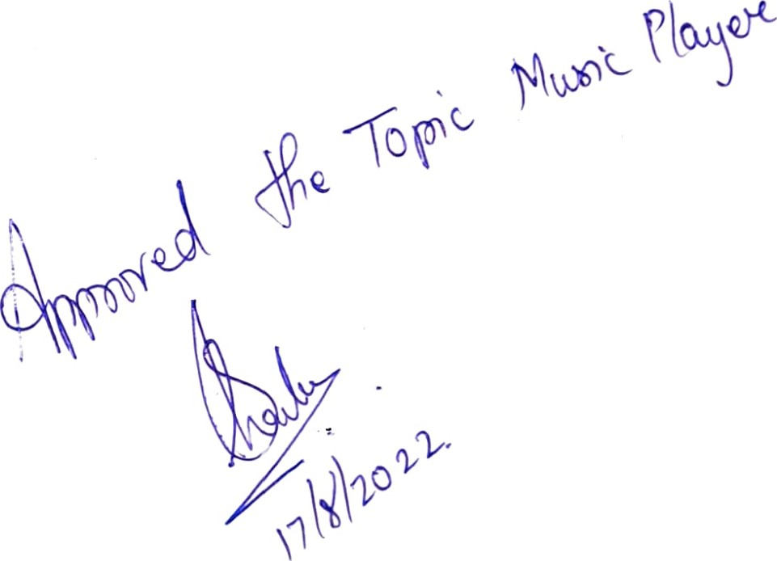HTML, CSS, JavaScript
* Java
* mySQL
* php